**CML4607F WEEK TWO**

**WHAT IS THE IRAC METHOD**

The IRAC method is a structured approach commonly used in legal analysis and writing to effectively address legal issues and reach well-reasoned conclusions.

1. **Identify The Legal Problem**

One has to carefully identify and define the legal issue at hand, while stating the relevant legal principles involved.

1. **Legal Requirements Applicable To This Legal Case**

One should identify and outline the legal rules, regulations, precedents, or other legal authorities that are relevant to the legal problem identified in the first step (identifying the key legal principles that will guide your analysis)

1. **Apply Requirements To The Case**

Proceed to analyse how these legal principles apply to the specific facts and circumstances of the case. This step involves applying the relevant legal rules to the facts of the case and assessing how they impact the outcome.

1. **Reach A Conclusion**

Draw a reasoned conclusion based on your analysis of the legal problem and application of the relevant legal requirements to the case. Your conclusion should be supported by your analysis and clearly address the legal issues raised. It may also involve discussing potential outcomes, implications, or recommendations based on your analysis.

**SOURCES OF LABOUR LAW**

1. **Legislation**

* Labour legislation is concerned with upholding fairness in the employment relationship
* It serves to limit employers' powers over employees and incorporates mechanisms to ensure equitable treatment.
* For instance, the enactment of legislation like the Minimum Wage Act supersedes common law practices and mandates employers to pay employees no less than the prescribed minimum wage. This legislative intervention ensures fairness in wage practices and regulates employer-employee relationships.
* Common law can be tempered where it is not based on fairness

1. **International and Foreign Law**

* International bodies like the International Labour Organization set standards for labour relations globally, which necessitates South Africa's compliance with these international norms.
* Adherence to international labour standards ensures that South Africa maintains alignment with global expectations regarding labour rights and working conditions.

1. **Common Law**

* The contract of employment, a form of common law, establishes the fundamental employment relationship between an employee and an employer.
* While many aspects of the employment relationship have been codified into legislation, contract law remains uncodified.
* Contract law is concerned with legality

Common law principles ensure that employment contracts adhere to legal standards and do not violate fundamental legal principles, regardless of their impact on individual parties.

1. **Case Law**

* Court rulings establish legal precedents that guide future interpretations of labor legislation and common law principles.

1. **Collective agreements**

* Collective agreements, permitted under the Labour Relations Act, function as agreements between employers and employees or their representatives. They are akin to subordinate legislation and bind all parties involved.
* These agreements allow parties to negotiate terms and conditions of employment collectively, ensuring that the interests of both employers and employees are considered and protected.

1. **Individual Employment Contracts**

* Individual employment contracts represent the specific agreements between individual employees and their employers.
* These contracts may vary in terms and conditions, reflecting the unique needs and circumstances of each employment relationship.
* When she refers to the individual employment relationship/contract, it refers to the employment relationship between the individual employee and the employer. (individual employment law)
* Each individual employee may bargain using the stipulations in their respective contracts
  1. **Five Fairness Mechanisms Contained in Labour Legislation**

1. **Establishment of minimum employment conditions**

* The Basic Conditions of Employment Act sets forth minimum standards for employment conditions, applicable to all employees.
* This includes regulations regarding working hours, overtime, and break time.
* You can agree in your employment contract for better conditions

1. **Encouragement of collective bargaining**

* Labor legislation encourages collective bargaining as a means for trade unions to represent employees and negotiate with employers on their behalf.
* This empowers employees to establish rights and advocate for their interests collectively.

1. **Concept of fair dismissal**

* Limits an employer's ability to terminate employment arbitrarily.
* Under the common law the employer was allowed to unfairly dismiss, before it was amended
* Employers are prohibited from dismissing employees unfairly, such as for engaging in lawful strikes.

1. **Protection Against Unfair Labour Practices**

* The employer has to treat the employee fairly during/after the employment relationship

1. **The labour legislation provides a special dispute resolution procedure and forum**

* Special courts… CCMA
* These specialized bodies provide a platform for resolving disputes between employers and employees outside of the traditional court system.

1. **Introduction of the minimum wage act**

**Collective Labour Law:**

* Collective labour law governs the relationship between trade unions representing employees and employers, as well as employer organizations (the employers' counterpart to trade unions).
* It primarily deals with negotiations and collective bargaining between these parties to establish terms and conditions of employment.
* For instance, the Chamber of Mines serves as an employer organization, representing the interests of employers in the mining industry.
* Strike actions can be considered a potent tool for employees to leverage during negotiations with employers, compelling them to engage in bargaining and potentially reach mutually acceptable agreements.

**Why Do You Think The State Has A Particular Interest In Protecting Employees?**

* A thriving workforce contributes to a stronger economy, leading to increased tax revenue for the state.
* Ensuring that employees are treated fairly and have access to decent working conditions promotes social stability and enhances overall welfare within society.
* Happy and satisfied employees are more likely to contribute positively to their communities and the economy.
* By promoting job security and fair labour practices, the state can reduce unemployment rates and alleviate associated social and economic challenges.
* When workers are adequately compensated and have access to benefits such as healthcare and retirement savings, they are less reliant on state assistance programs.
* Countries with healthy labour relations and robust employee protections are more attractive to investors.

**Labour Law Regulates Various Rights And Obligations**

1. **Individual Rights and Obligations**:

* Governed primarily by the Labour Relations Act 66 of 1995 (LRA) and the Basic Conditions of Employment Act 75 of 1997 (BCEA).
* Examples include the right not to be unfairly dismissed and the right to receive payment for overtime work.
* This is between employer and employee

1. **Collective Rights**:

* Primarily regulated by the LRA.
* Examples include the right to join a trade union and the right to engage in lawful strike action.

1. **Anti-Discrimination Rights and Obligations**:

* Governed primarily by the Employment Equity Act 55 of 1998 (EEA).
* Examples include the right not to be subjected to discrimination in the workplace and the obligation of employers to implement affirmative action measures.

1. **Social Security Rights**:

* Governed by various statutes, such as the Unemployment Insurance Act 63 of 2001 (UIA) and the Compensation for Occupational Injuries and Diseases Act 130 of 1993 (COIDA).
* Examples include the right to receive unemployment insurance benefits when unemployed and the right to compensation for injuries sustained at work.

**WHO IS AN ‘EMPLOYEE’?**

* + An agreement between two or more persons in terms of which the employee agrees to provide their personal services to the employer, under the control of the employer, in return for remuneration by the employer.
  + Parties involved: employee and employer

The definition of an employee as outlined in legislation, specifically Section 213 of the Labour Relations Act (LRA), encompasses individuals who meet the following criteria:

1. Individuals who work for another person or the state, excluding independent contractors, and who receive or are entitled to receive remuneration for their services.
2. Individuals who contribute to the continued operation or conduct of the employer's business in any capacity.

* Excluded from this definition are independent contractors and individuals serving in specific roles such as within the Defence Force or Intelligence sectors.
* The distinction between employees and independent contractors has its origins in common law, with roots tracing back to Roman law principles
* Employment contracts during Roman time was a lease agreement (you lease your personal services to someone else)
* The concept of *"locatio conductio operis*" pertains to contracts for the completion of specific tasks or projects, typically associated with independent contractors.
* Conversely, *"locatio conductio operarum"* involves contracts for the provision of personal services, aligning more closely with the employer-employee relationship as defined in employment contracts.
* In any labour dispute, the initial inquiry often revolves around determining whether the individual is classified as an employee or an independent contractor (due to jurisdictional implications)
* If deemed an independent contractor, the CCMA lacks authority to adjudicate the dispute.
* Independent contractors must seek resolution through civil courts, typically for breach of contract claims, as they fall outside the definition of the Labour Relations Act.
* Notably, independent contractors do not benefit from protections against unfair labour practices or dismissal afforded by the Labour Relations Act. Conversely, employees can seek recourse for unfair dismissal under this legislation.

**Different Tests Developed By The Courts**

These tests are used to determine whether someone is an employee or a contractor

1. **Control test:**

* Someone is an employee if the employer has control over them.
* e.g. Working hour determined by the employer

1. **Organisation test:**

* Asks whether this person is part of the employers organisation…
* e.g. does this person have an office, is his person provided with tools to work…
* due to the changing world of work ,this test was not sufficient

1. **Dominant impression test:**

* Weighs the factors that are in favour of the person being an employee against the factors that the person may be an indeoendant contractor.
* So, the court will look at how the employee is integrated within the workplace.

**Presumption That The Person Is An Employee**

Factors that create a presumption that the person is an employee: contained in section 200A of the LRA. These factors only apply to vulnerable employees (earning below threshold amount: R241 110,59 per year effective from 1 March 2023).

*If any one of these factors applies, then the person is an employee*

* Manner of work subject to the control/direction of another person;
* Work hours subject to the control/direction of another person;
* Person forms part of the organisation;
* Worked for an average of at least 40 hours per month over the last 3 months;
* Economically dependent
* Provided with tools of trade or work equipment
* Only works for or renders services to one person.

The employer would then have to provide evidence showing why the person is not an employee. If the employer is unable to do that, then this legislative presumption is applicable, and the person has been presumed to be an employee. The CCMA for example, would be able to hear the case and have jurisdiction.

We particularly apply the dominant impression test to weigh up all the factors and then the court will use this to determine if the person is an employee (this is still applicable to employees earning above the threshold)

**ESSENTIALA OF AN EMPLOYMENT CONTRACT**

Essentialia refers to what is necessary to make the contract a specific type of contract. For example, a lease agreement would have different *essentiala* to an employment contract.

So, in terms of legislation there are sometimes certain formalities that contractor adhere to and employment contracts do not have to be in writing except if it is an a fixed term employment contract or in the case of for example and training contracts (So auditing clerks or candidate attorney.)

Common Law requirements for a valid employment contract:

* + 1. 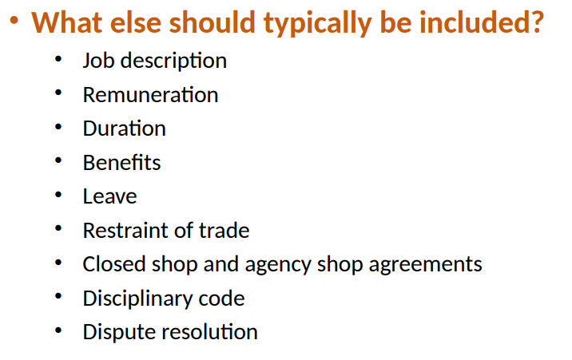Consensus (agreement)
    2. Legal capacity
    3. Possibility of performance
    4. Legality
    5. Formalities: Need not be in writing (verbal, tacit conclusion possible) EXCEPT where required by legislation (e.g., auditing clerks)

Further requirements:

1. Employee must make their services available
2. Employer must pay the employee

An employer will provide as part of the packet or email or whatever you receive you will also receive the disciplinary code. So it might be that your employment contract, for example, states, that the disciplinary code that you will be provide with is included in this contract, which they means that the employer may except that you've read the disciplinary code, and that you are aware of the disciplinary code and the procedures in it.

So, where you are, for example, guilty of misconduct, it's also breach of contract.

There might be two causes of action, arising out of one incident. So, the case this is an example of that. So, it might be misconduct, which is a contravention of the disciplinary code. And which then would lead to a claim in terms of the labor relations act, but it might also be, um, a bridge of contract. So then technically the employer could then approach the civil courts with a breach of contract claim.

**IMPLIED DUTIES OF EMPLOYEES (COMMON LAW DUTIES)**

So, opening a business that directly competes with the employer is obviously then a breach of this implied duty of good faith. And for that reason, that it is possible to include a restraint of trade clause within the contract.

**IMPLIED DUTIES OF EMPLOYERS (COMMON LAW DUTIES)**

**TERMINATION OF EMPLOYMENT**

Employment can be terminated by way of:

1. **Completion of the contract:**

* In fixed-term employment, termination occurs upon completion of the specified project or expiration of the contract term. No notice period is typically required.
* Indefinite contracts, often termed permanent, may conclude upon reaching retirement age or fulfilling specific conditions.

1. **Cancellation**:

* Breach of contract by either party allows for cancellation. Repudiation, indicating an intent not to uphold the contract, constitutes a form of breach.
* Procedural fairness, integral to dismissal, may necessitate alternative approaches if disciplinary procedures are impractical.
* Conducting a disciplinary hearing for absenteeism, particularly in cases where an employee has been consistently absent for two weeks due to being unlocatable, would prove impracticable for the employer.
* So, it would be easier to go the cancellation route and easier to replace the employee

1. **Agreement**

* Mutual agreement to terminate employment may occur if an employee secures another job or relocates. Notice periods are typically required in terms of the basic conditions of employment act.
* Failure to serve notice may constitute breach, allowing the employer to claim specific performance or damages. (where the court just tell the employee to perform in terms of the contract)
* The employer can claim damages while accepting the exit of the employee
* If you worked for more than a year, then your notice period within any event would then be 30 days
* Constructive dismissal:
  + Sometimes, an employer may desire an employee's resignation but hesitates to formally dismiss them due to the lack of justifiable reasons for termination.
  + The three permissible reasons for dismissal are operational requirements, misconduct, and incapacity (due to ill health or incompetence).
  + In cases of constructive dismissal, the employer creates working conditions so intolerable that the employee is effectively compelled to resign.
  + Where an employee resigns but is able to prove that they didn’t resign out of free will, but actually because of the employer made continued employment intolerable, then it is seen as a dismissal (constructive dismissal).
  + The employee can now rely on the protection in the Labour Relations Act and claim unfair dismissal against the employer
  + It's crucial to differentiate between poor work performance attributable to misconduct and incompetence resulting from factors beyond the employee's control.

1. **Death**

* In cases of individual employees, death terminates the employment relationship. For corporations, individuals are replaced.

1. **Insolvency**

* An employee's insolvency does not affect the employment contract.
* If the employer becomes insolvent, employment may be terminated if the business cannot continue. Outstanding remuneration remains owed.

1. **Impossibility of performance**

* This also links to disability

**BREACH OF CONTRACT AND REMEDIES**

The Labour Relations Act (LRA) provides three potential remedies for unfair dismissal:

* + Reinstatement (in the same position) - same as specific performance in terms of Common Law
  + Re-employment in another suitable position
* Because these cases can take time, the remedy cannot be reinstatement (cannot replace the person that has replaced the dismissed employee)
  + Compensation
* CCMA agrees on constructive dismissal, so the CCMA would order compensation
* Only entitled to a maximum of 12 months remuneration compensation from CCMA

**SELECTED ISSUES**

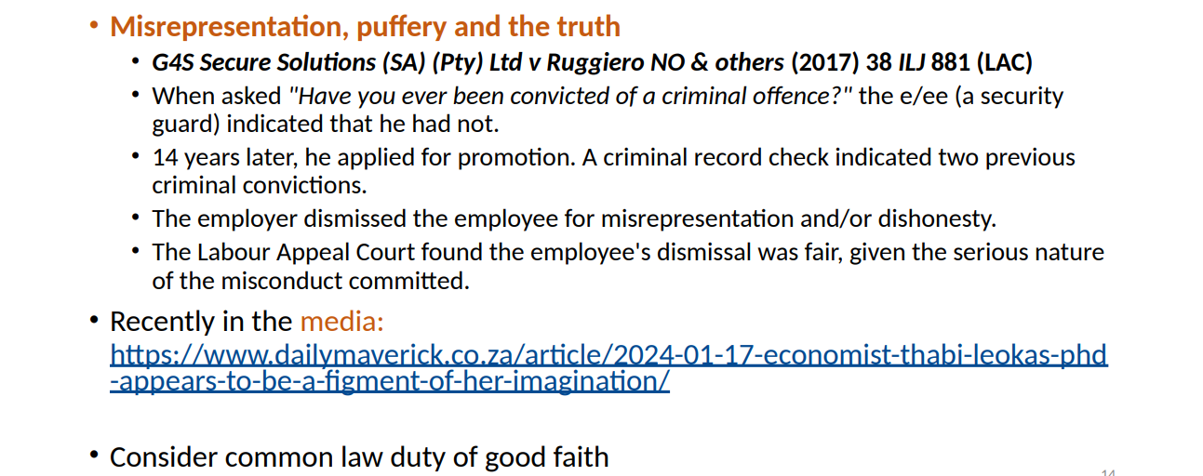**Job Applications**

We must address the issue of misrepresentation or fraudulent CVs, which constitutes a violation of your obligation to act in good faith under common law and is considered a form of misconduct, warranting dismissal for dishonesty.

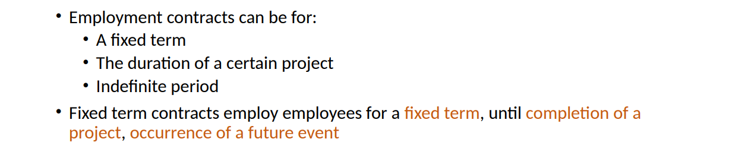**Fixed Term Employment**

* Employers saw that they could abuse the system by appointing fixed term employees.
* Terminating their employment is simpler (as it's automatically terminated), and there's no obligation to provide benefits to fixed-term employees.

The LRA was amended to prevent the abuse:

* Section 186(1)(b) LRA: Introduces the concept of a "reasonable expectation of renewal" for fixed-term contracts (above the threshold)
* Section 198B LRA: Limits the duration of fixed-term contracts to a maximum of 3 months, unless justified by specific reasons. If an employee, earning below the threshold, is appointed for longer than 3 months without valid justification, they are considered to be indefinitely employed. This provision applies exclusively to employees below the threshold.
* Section 198B: Ensures that employees on fixed-term contracts are not treated less favourably than permanent employees.

The notion of a "reasonable expectation" extends beyond mere subjective belief, requiring substantiation with objective evidence (the employer may express interest in making the employee a part of the business for another year or the employee is involved in a project that end the following year)

Subsequently, if the employee is deemed to have been unfairly dismissed, they are entitled to the same remedies provided by the LRA as those available to employees unfairly dismissed under other circumstances. The exceptions for fixed-term contracts are listed below.

**Restraint Of Trade**

Restraint of trade clauses serve to safeguard trade secrets, intellectual property, and client relationships. Although restraint of trade clauses are not codified in labour legislation, they find their basis in common law. They entail a delicate balance between two conflicting principles:

* The sanctity of contract, a common law principle that upholds the validity and enforceability of contractual agreements.
* The constitutional right to freedom of trade and profession, as outlined in Section 22 of the Constitution.

These clauses are commonly found in contracts such as the sale of a business, where they protect the goodwill of the enterprise (business reputation and clients), and in employment contracts, where they safeguard trade secrets, customer relationships, and intellectual property.

These clauses become active only after the termination of the employment contract.

Their purpose is to prevent former employees from engaging in activities that would compete with the interests of their previous employer. Without such clauses, employees may engage in outside work but are restricted from activities that directly conflict with their employer's interests.

In evaluating the reasonableness of a restraint of trade clause, several factors come into play:

1. **Public Interest**:
   * If enforcing the restraint is contrary to the public interest, it is deemed unreasonable.
2. **Legitimate Interest**:
   * The party seeking to enforce the restraint must demonstrate a legitimate interest to protect, such as trade secrets or client relationships.
3. **Scope of Restraint**:
   * The restraint should be tailored to protect only the legitimate interest in question and should not extend beyond what is necessary for protection.
4. **Duration**:
   * The duration of the restraint should be reasonable and proportionate to the interest being protected.
5. **Geographical Area**:
   * The geographical area covered by the restraint should be reasonable and relevant to the legitimate interest.
6. **Scope of Activity**:
   * The scope of activities restricted by the clause should be limited to those directly related to the legitimate interest.

If the clause is unreasonable, the court would be able to sever the unreasonable part

Legitimate interests, in the context of restraint of trade clauses, encompass various aspects that hold economic value to the party seeking protection. These may include:

1. **Trade Secrets**:
   * Information that:
     + Can be applied in trade or industry,
     + Is not publicly known or available,
     + Is known only to a restricted number of individuals, and
     + Holds economic value for the party seeking protection.
2. **Confidential Information**:
   * Data or knowledge that is not publicly disclosed and is deemed confidential by the employer.
3. **Client/Customer Connections**:
   * Relationships established with clients or customers, including knowledge of their preferences, needs, and business practices, which provide a competitive advantage to the employer.

**Probation**

During probation, newly appointed employees undergo a trial period, allowing the employer to assess their performance before confirming their appointment. This evaluation period offers both parties the opportunity to gauge suitability for the role and organizational fit, ensuring informed decisions regarding long-term employment.

However, it's essential to use probation responsibly, ensuring it does not undermine employees' rights to permanent employment. The duration of the probationary period should be predetermined and reasonable, often lasting around three months.

Throughout the probationary period, employers should diligently assess the employee's performance. If performance falls below the expected standard, the employer should offer guidance, counselling, or training to assist the employee in improvement efforts. In cases of continued incompetence, despite support and guidance, the employer may choose to extend the probationary period or initiate a fair dismissal process. This approach ensures that probation serves its intended purpose of assessing performance while upholding fairness and respect for employees' rights.

**Salary Levels & Overtime**

Salary levels and overtime are regulated by the Basic Conditions of Employment Act (BCEA), which aims to establish minimum standards for terms and conditions of employment. However, these standards do not prohibit employers from offering better employment terms, as long as they adhere to the BCEA's minimum requirements.

According to Section 10 of the BCEA, employees must agree to work overtime, and no more than 10 hours of overtime per week are permitted. Overtime must be compensated at a rate of 1.5 times the employee's regular wage.

However, it's important to note Section 6 of the BCEA, which exempts "senior managerial employees" (SMEs) and employees earning above the annual salary threshold from overtime pay. While these individuals are not entitled to overtime pay by law, their employment contracts may still include provisions for overtime compensation.

**Private Life & Conscience**

The concept of a loyal and obedient employee can sometimes clash with statutory provisions that encourage employees to challenge, negotiate, confront, speak out, report wrongdoing, and even participate in strikes.

Section 77 of the Labour Relations Act (LRA), for instance, grants workers the right to engage in socio-economic protests, while constitutional rights further allow individuals to express themselves, assemble, and associate freely. Courts have ruled that criticizing employers in a published manner, as long as it's not dishonest or malicious and doesn't target specific managers, typically does not warrant dismissal.

**Disability & Incapacity**

Disability and incapacity considerations in the workplace involve assessing when an illness or condition qualifies as a disability. According to the Code of Good Practice on the Employment of People with Disabilities, individuals must meet specific criteria to be regarded as having a disability:

1. The impairment is long-term or recurring.
2. The impairment is physical or mental in nature.
3. The impairment substantially limits the employee's prospects of entering or advancing in employment.

**Private Remunerative Work**

Private remunerative work is governed by principles that have historical roots in Roman law, particularly the concept of *locatio conductio operarum*, which emphasizes that employees should be fully available to their employers. This means that employees are obligated to further the employer's business interests and dedicate all normal working hours to their employer's needs.

Employees are expected to avoid situations where their personal interests conflict with those of their employers. They cannot engage in activities that compete with their employer's business, and any potential conflicts of interest must be disclosed before employment begins.

Private remunerative work is often subject to Outside Employment Policies (OEPs), which are guidelines established by employers to regulate employees' engagement in secondary employment while still employed. These policies resemble restraints of trade clauses found in contracts but are enforced during the duration of employment rather than after it.

The primary purpose of OEPs is to address various legitimate concerns, including:

1. Conflicts of interest: Preventing situations where an employee's outside employment may conflict with their duties or interests within the organization.
2. Avoidance of secret profits or commission: Ensuring transparency and fairness in all financial dealings related to employment.
3. Distractions from job performance: Minimizing disruptions to an employee's work quality or schedule caused by secondary employment.
4. Misuse of employer's resources: Preventing employees from utilizing company resources for personal gain or outside ventures.
5. Avoiding the appearance of impropriety: Upholding the organization's reputation by avoiding actions that could be perceived as unethical or inappropriate.
6. Misrepresentation or confusion: Preventing situations where outside employment may cause confusion or misrepresentation of the employee's role or affiliation with the organization.

**Whistleblowing**

Whistleblowing is safeguarded by the Protected Disclosures Act 26 of 2000 (PDA), which shields whistleblowers who report information in good faith and honesty, and reasonably believe it to be true. This act outlines specific procedures and entities to which disclosures can be made.

Section 3 of the PDA prohibits employers from subjecting employees to any form of occupational detriment as a result of making a protected disclosure. Occupational detriment refers to negative consequences imposed on an employee by the employer, which may include dismissal, disciplinary action, demotion, or any other adverse treatment.